**DAY 6 SQL ASSIGNMENT**

**1.Categorize products by stock status**

(Display product_name, a new column stock_status whose values are based on below condition) (units_in_stock = 0 is 'Out of Stock' units_in_stock < 20 is 'Low Stock')

SELECT

PRODUCT_NAME,

CASE

WHEN UNITS_IN_STOCK = 0 THEN 'Out of Stock'

WHEN UNITS_IN_STOCK < 20 THEN 'Low Stock'

ELSE 'In Stock'

END AS STOCK_STATUS

FROM PRODUCTS;

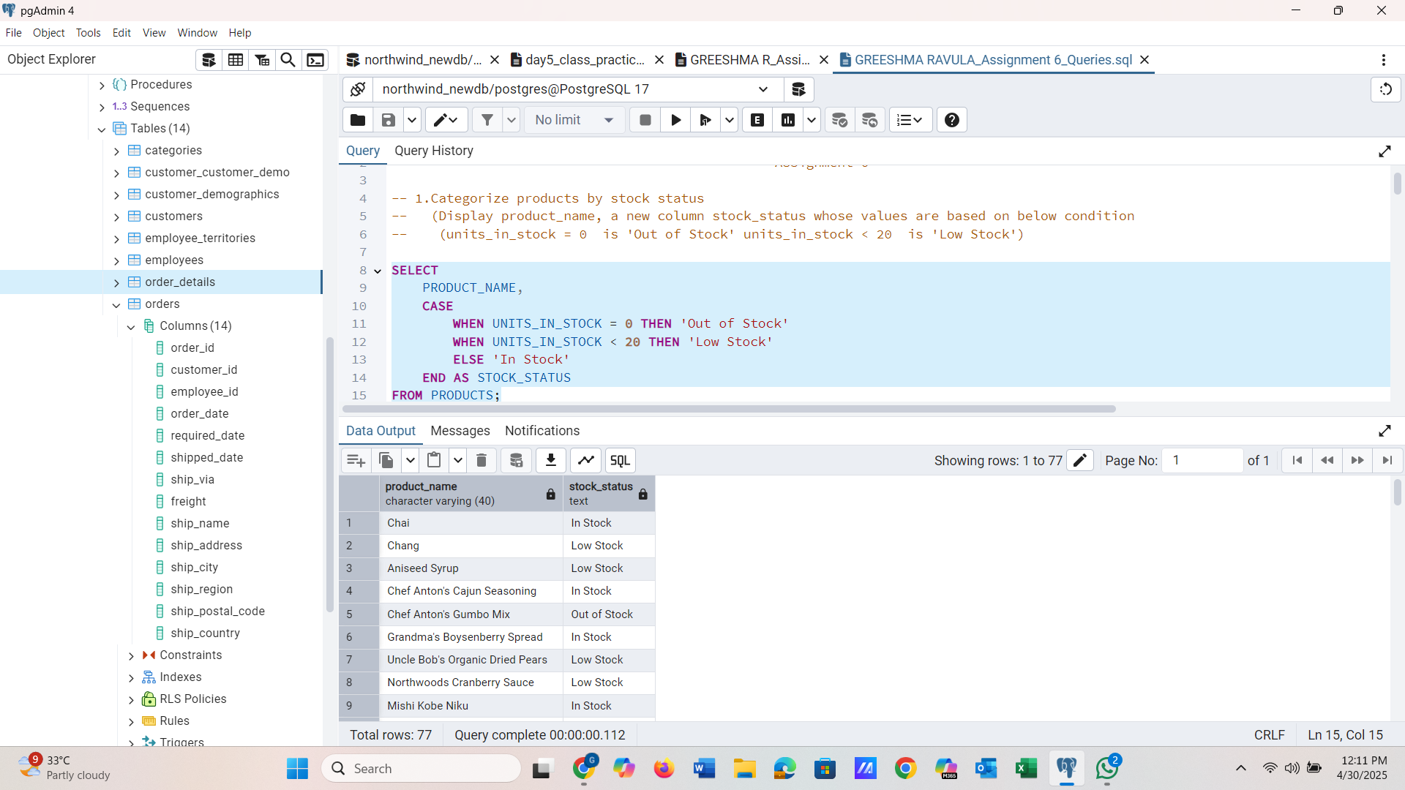

-------------------------------------------------------------------------------------------------------------------------------

**2.Find All Products in Beverages Category**  (Subquery, Display product_name,unitprice)

SELECT

PRODUCT_NAME,

UNIT_PRICE

FROM

PRODUCTS

WHERE

CATEGORY_ID = (

SELECT

CATEGORY_ID

FROM

CATEGORIES

WHERE

CATEGORY_NAME = 'Beverages'

);

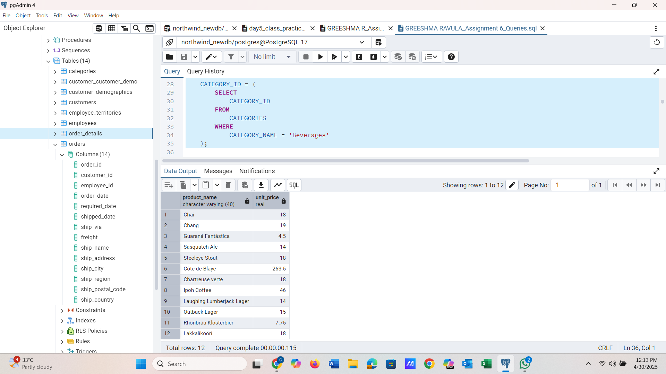

-------------------------------------------------------------------------------------------------------------------------------

**3.Find Orders by Employee with Most Sales**

(Display order_id, order_date, freight, employee_id.

Employee with Most Sales=Get the total no.of of orders for each employee then order by DESC and limit 1. Use Subquery)

SELECT

ORDER_ID,

ORDER_DATE,

FREIGHT,

EMPLOYEE_ID

FROM

ORDERS

WHERE

EMPLOYEE_ID = (

SELECT

EMPLOYEE_ID

FROM

ORDERS

GROUP BY

EMPLOYEE_ID

ORDER BY

COUNT(*) DESC

LIMIT

1

);

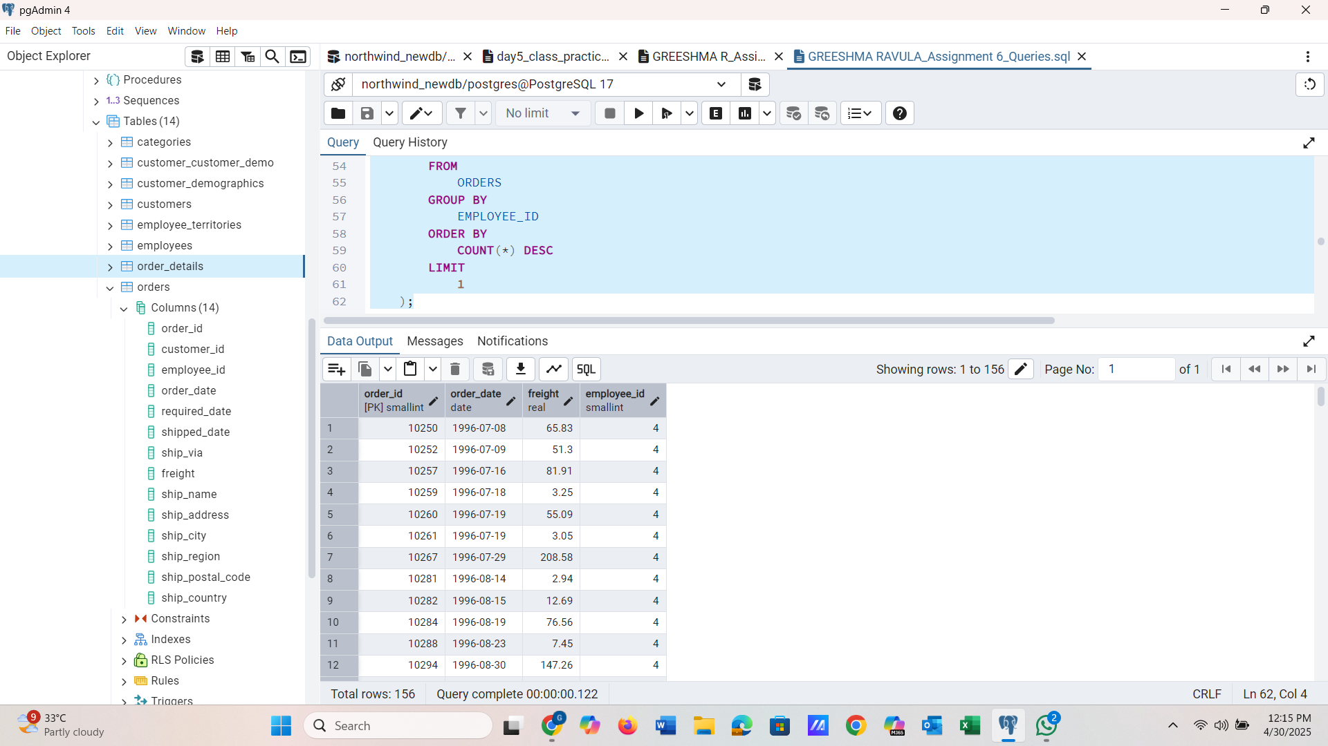

-------------------------------------------------------------------------------------------------------------------------------

**--4.Find orders where for country!= ‘USA’ with freight costs higher than any order from USA.**  (Subquery, Try with ANY, ALL operators)

**Any**

SELECT

ORDER_ID,

CUSTOMER_ID,

FREIGHT,

SHIP_COUNTRY

FROM

ORDERS

WHERE

SHIP_COUNTRY != 'USA'

AND FREIGHT > ANY (

SELECT

FREIGHT

FROM

ORDERS

WHERE

SHIP_COUNTRY = 'USA'

);

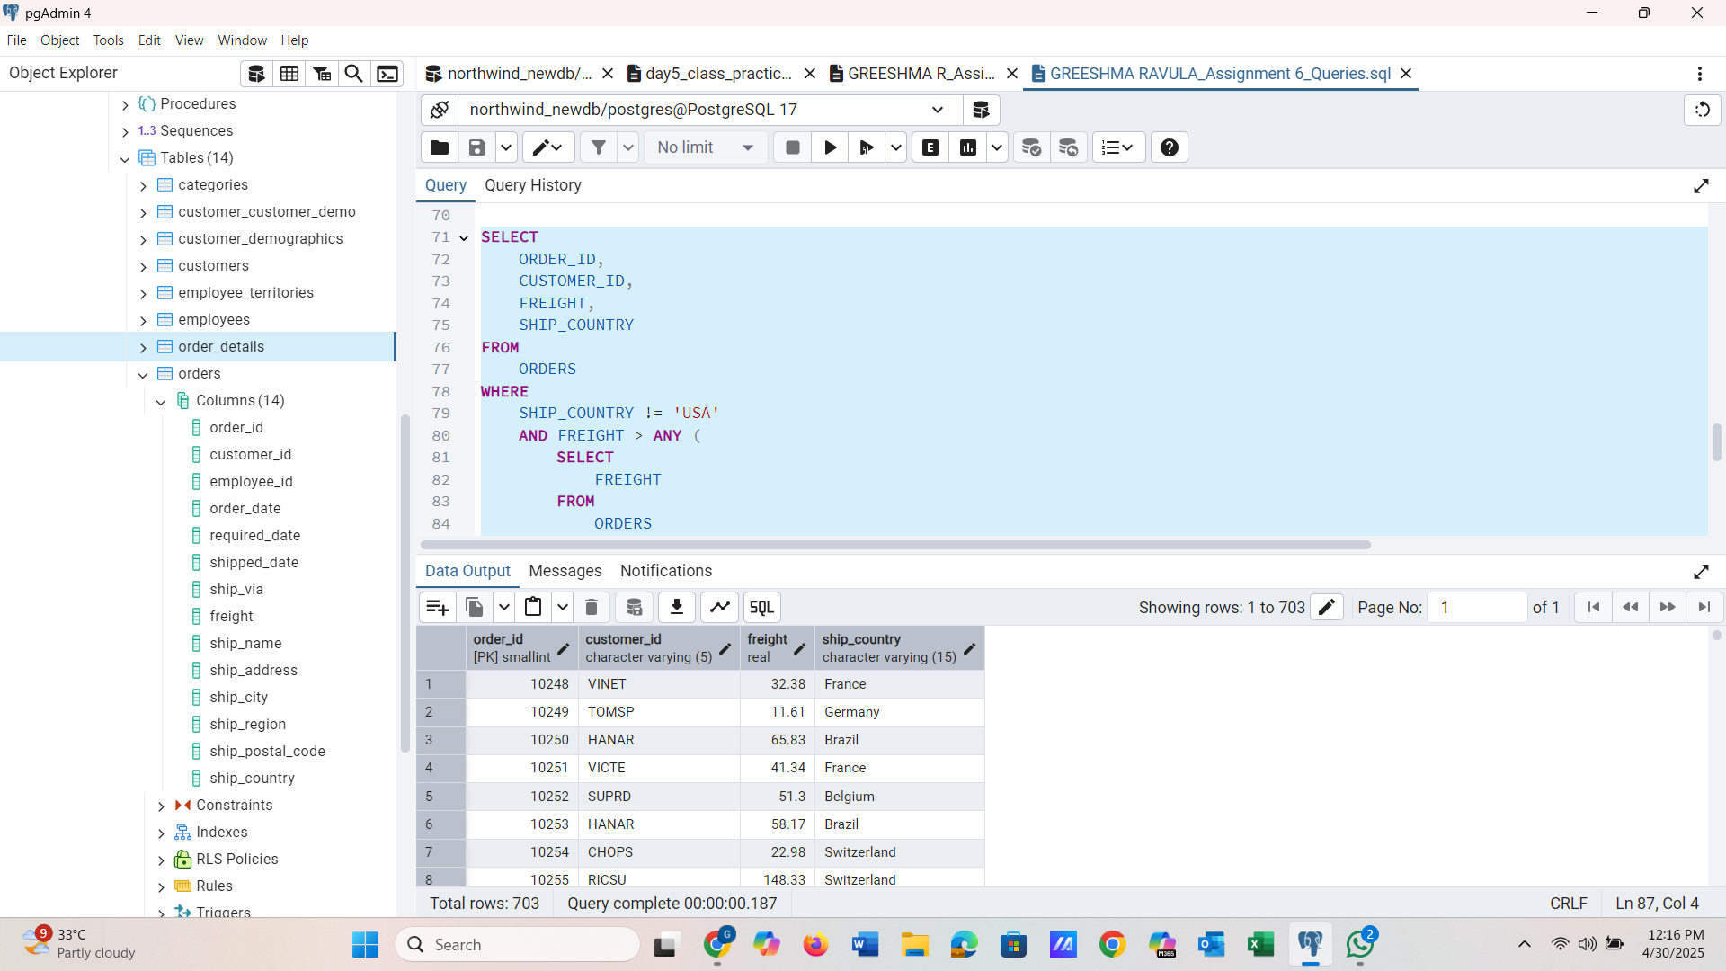

**ALL**

SELECT

ORDER_ID,

CUSTOMER_ID,

FREIGHT,

SHIP_COUNTRY

FROM

ORDERS

WHERE

SHIP_COUNTRY != 'USA'

AND FREIGHT > ALL (

SELECT

FREIGHT

FROM

ORDERS

WHERE

SHIP_COUNTRY = 'USA'

);

